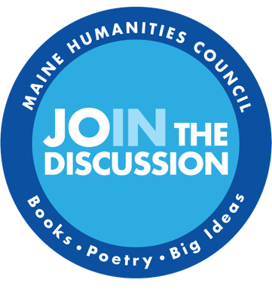

**Mini Grant Application | Narrative Drafting Space**

This document is meant to be a space to work out responses to narrative questions ahead of time. It covers only the long-answer questions in the “About your project” section of our application. You will need to copy-and-paste finished responses into our online form when you are ready to submit.

**Please be aware: there is a 3000 CHARACTER limit (NOT a word limit) on all long-answer questions in this section.** This includes spaces. Any responses over 3000 characters will get cut off.

* **Describe your project and its goals.**
* **Describe the role of the humanities in your project.**
* **What content experts will be involved with this project and how will they be contributing?**
* **[If you answered yes to “*Will a fee be charged for any public activities associated with your event?*”] Please explain the fees.**
* **Who is your intended audience for this project and why?**